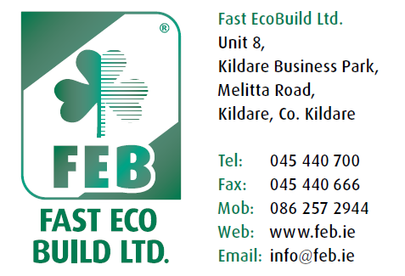
Site Inspection Report
Site Address. Contractor. Job No.

Stage 1. Preparation.  Comments:-  Signed FEB:- | Date. ______  Temp.  Weather Cond.  Signed Contractor:-
Stage 2. Boarding.  Comments:-  Signed FEB:- | Date. ______  Temp.  Weather Cond.  Signed Contractor:-
Stage 3. Base Coat.  Comments:-  Signed FEB:- | Date. ______  Temp.  Weather Cond.  Signed Contractor:-
Stage 4. Finish Coat.  Comments:-  Signed FEB:- | Date. ______  Temp.  Weather Cond.  Signed Contractor:-
Stage 5. Completion.  Comments:-  Signed FEB:- | Date. ______  Temp.  Weather Cond.  Signed Contractor:-

